**BASICS ON THE GPS TRACKING COMPONENTS USED :**

The NEO-6M GPS module is a popular GPS receiver used in electronics and embedded systems to provide real-time positioning, velocity, and timing information. It’s often used in drones, robots, and other GPS-based systems.

**How the NEO-6M GPS Module Works:**

1. **GPS Signal Reception:**

The NEO-6M GPS module uses satellites in the Global Positioning System (GPS) to determine its location. GPS satellites transmit signals that the module receives via its antenna. The module listens to signals from at least 4 GPS satellites, which allows it to triangulate its position.

1. **Data Processing:**

Each satellite sends a signal containing its position and the exact time the signal was sent.The module calculates the time delay between the signal’s transmission and reception. This time difference helps determine the distance to each satellite.

1. **Accuracy and Time to Fix:**

The NEO-6M can typically achieve an accuracy of about 2.5 meters (under optimal conditions).It may take some time to acquire a "fix" (initial positioning lock), which can range from a few seconds to a few minutes, depending on the environment.

**BASICS ON ARDUINO UNO MODULE :**

The Arduino Uno is one of the most popular microcontrollers used for beginner and advanced electronics projects. It's built around the ATmega328P microcontroller and is easy to program using the Arduino IDE. Here are the core features and functionalities of the Arduino Uno:

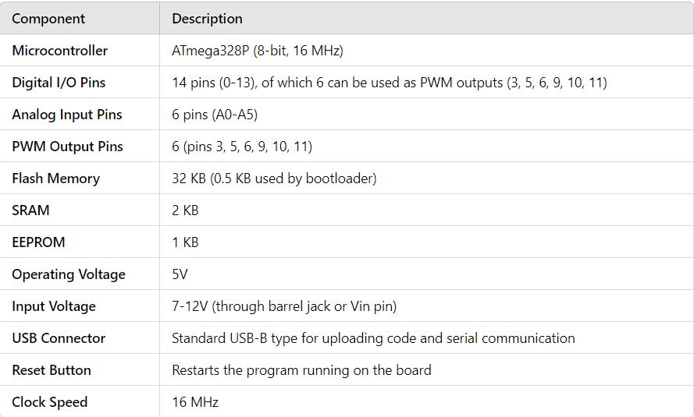

**Programming the Arduino Uno**

The Arduino Uno is programmed using the Arduino IDE, which supports a simplified version of C/C++. Here's the typical workflow for programming it:

**a. Installing the Arduino IDE**

Download and install the Arduino IDE on your computer.

Connect the Arduino Uno to your computer via the USB cable.

**b. Arduino Sketch**

Arduino programs are called sketches. A sketch consists of two main functions:

1. **void setup():**

**Runs once when the board is powered on or reset. Used to set up initial conditions like pin modes.**

1. **void loop():**

**Repeatedly runs after setup(). This is where the main logic goes.**

**(CONTENTS UNDER NOT ASSOCIATED WITH GPS TRACKING, JUST FOR UNDERSTANDING THE ARDUINO UNO MODULE WORKING)**

**-----------------------------------------------------------------------------------------------------------------------------**

1. **SKETCH CODE EXAMPLE FOR BLINKING LED :**

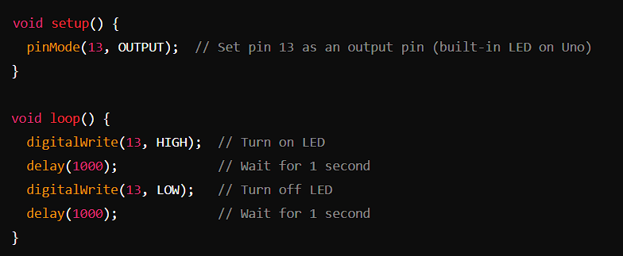

1. **SERIAL COMMUNICATION**

Serial Monitor: The Arduino Uno can send and receive data to and from your computer via the USB connection. You can use the Serial Monitor in the Arduino IDE (found under Tools > Serial Monitor) to view data from the Arduino.

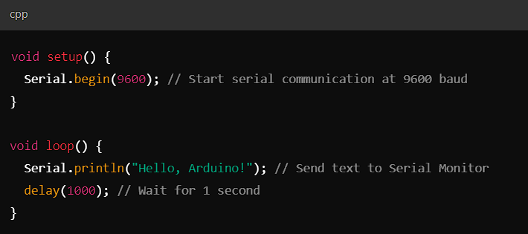

**-------------------------------------------------------------------------------------------------------------------------------**

**Uploading Code**

After writing the sketch, select the board and port:

1.Go to Tools > Board > Select "Arduino Uno".

2.Go to Tools > Port > Select the port where your Arduino is connected.

3.Click the Upload button in the IDE to upload the code to the Arduino.

The Arduino will start running the uploaded code automatically.

**Powering the Arduino Uno**

The Uno can be powered via:

USB connection (5V) – typically used when connected to a computer.